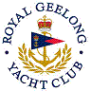 | Royal Geelong Yacht Club Inc.  Est 1859
Trophy Deed of Gift.

Trophy: | Two-Handed Series Perpetual Trophy
Presented by: | Geelong Short Handed Sailing Association
Date:
For: | Combined Divisions Two Handed Aggregate
Remarks / Revisions
Click here for a List of Recipients
